FACILITIES RENTAL INFORMATION & RATES

The Longbranch Improvement Club (LIC) is a large historical venue facility on the Key Peninsula, and is frequently rented for weddings, family gatherings, corporate events, fund raisers, shows and a variety of other uses.

Featuring a large ballroom capable of seating up to 300 people, a stage with event lighting, audio systems, restrooms, a full kitchen with a foyer meeting area capable of seating 50 people, this is a very versatile facility. With a disco ball and large hardwood floors, it’s routinely configured for both weddings and reception celebrations. With beautiful grounds, nature trails and extensive parking, the LIC is the premier facility on the Key Peninsula.

The LIC schedule is found on our website www.licweb.org where you can see facility availability. For more information, contact Kitty Voyce, phone 360-649-3594, email licclubhouserentals@gmail.com . We suggest planning your rental reservation as far in advance as possible, so you can have your desired dates.

The steps to planning your amazing event is simple – review our rental prices, agreement, facility info, and then reach out to Kitty to tour the facility and finalize your plans.

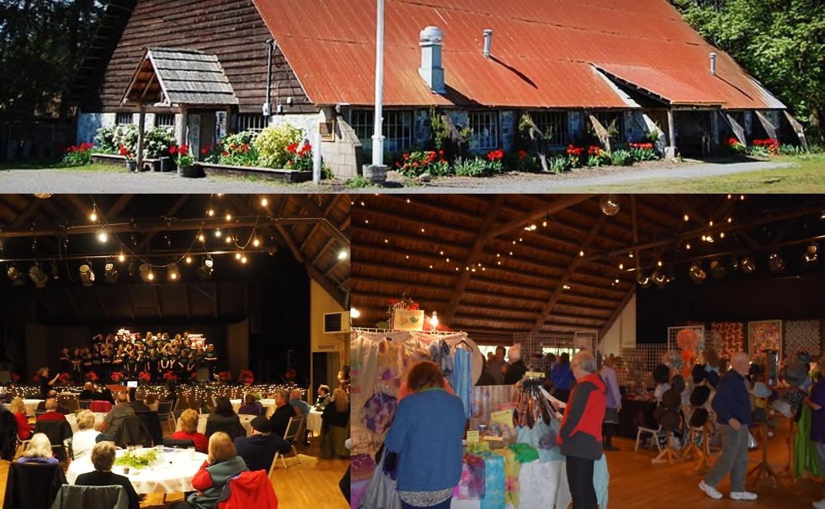

RENTAL RATES & FEES:  (Effe cti ve Ja n u a ry 1, 2019) |  | Foyer Meeting  Room (No Kitchen Usage)* |  | Ballroom, Foyer Meeting Room (No Kitchen Usage)* |  | Ballroom, Foyer  & Operating  Kitchen* |  | Outdoor Spaces Only* |  | Ballroom, Foyer, Operating Kitchen & Outdoor Spaces*
FACILITY RENTAL
Half Day Rentals - Mon - Tue - Wed - Thurs:
8:00 a m - 12:00 pm |  | $75.00 |  | $500.00 |  | $650.00 |  | $100.00 |  | $700.00
2:00 pm - 11:00 pm |  | $75.00 |  | $500.00 |  | $650.00 |  | $100.00 |  | $700.00
Half Day Rentals - Fri - Sat - Sun:
8:00 a m - 12:00 pm |  | $75.00 |  | $550.00 |  | $700.00 |  | $100.00 |  | $750.00
2:00 pm - 11:00 pm |  | $75.00 |  | $600.00 |  | $700.00 |  | $100.00 |  | $800.00
Full Day Rentals - Mon - Tue - Wed - Thurs:
8:00a m - 11:00pm |  | $125.00 |  | $800.00 |  | $1,100.00 |  | $150.00 |  | $1,200.00
Full Day Rentals - Fri - Sat - Sun:
8:00a m - 11:00pm |  | $150.00 |  | $1,000.00 |  | $1,200.00 |  | $200.00 |  | $1,300.00
3 Full Day Rental Package (Fri, Sat & Sun) |  | $250.00 |  | $2,500.00 |  | $2,800.00 |  | $800.00 |  | $3,200.00
SECURITY DEPOSITS AND ADDITIONAL CHARGES
Refundable Security Deposit: |  | $200.00 |  | $500.00 |  | $600.00 |  | $200.00 |  | $700.00
November to February Heating Surcharge: |  | $50 ½ Da y, $75  Ful l Da y |  | $100 ½ Da y,  $150 Ful l Da y |  | $100 ½ Da y,  $150 Ful l Day |  | N/C |  | $100 ½ Day,  $150 Ful l Da y
PA System with Assisted Set-up/Tear Down: |  | $200.00 |  | $200.00 |  | $200.00 |  | N/A |  | $200.00
Outdoor Electrical Power (80amp) with  Assisted Set-up/Tear Down: |  | N/A |  | N/A |  | N/A |  | $100.00 |  | $100.00
LCD projector and screen with Assisted  Set-up /Tear Down: |  | $300.00 |  | $300.00 |  | $300.00 |  | N/A |  | $300.00
Security Deposit on AV & Outdoor Power: |  | $100.00 |  | $100.00 |  | $100.00 |  | $100.00 |  | $100.00

* Rental Includes:
Foyer Meeting Room: 6' round tables & chairs, seats 50.
Ballroom Only: 6' round tables or 6' & 8' classroom style tables, with chairs, seating up to 300.
Operating Kitchen: Stove for food reheating, refrigeration, plates, flatware, coffee pots, coffee cups, water glasses & microwave.
Outdoor Spaces: Use of grounds for events and weddings. Port-a-potties must be provided by renter if Ballroom is not rented. All rentals include guest passenger car parking during the rental period (no overnight parking or camping allowed without prior authorization)
3 Full Day Rental Package: Starts at 8:00am on Friday, ends at 5:00pm on Sunday.

Heating Surcharge - The Longbranch Improvement Club building is on the National Register of Historic Places, and during periods of cold weather is inefficient to heat. During November through February, a heating surcharge as noted above will apply.
Audio, Outdoor Power and LCD Projector/Screen - requires professional set-up and tear-down, availability requires confirmation.

Rental Discounts:

Longbranch Improvement Club Qualified Members and active duty military receive a 25% off the rental rates, fees and additional options rates above. These discounts do not affect deposit amounts.

